Rolling Environment Mapper



Project Proposal

Rolling Environment Mapper
Brandon Le
Kiet Nguyen
Hai Yen Nguyen
Antony Quach
Josh Wu

Department of Computer Science
Texas A&M University

Feb 13, 2026
Table of Contents (Be sure to regenerate before submitting).

1 Executive summary (1 page; 5 points) 2
2 Introduction (1 page; 20 points) 4
2.1 Needs statement (5 points) 4
2.2 Goal and objectives (10 points) 4
2.3 Design constraints and feasibility (5 points) 4
3 Literature and technical survey (1-2 pages; 10 points) 5
4 Proposed work (35 pts) 6
4.1 Evaluation of alternative solutions (1 page, 10 points) 6
4.2 Design specifications (3-4 pages, 20 points) 7
4.3 Approach for design validation (1 page, 5 points) 10
5 Engineering standards (25 points) 11
5.1 Project management (1 page, 10 pts) 11
5.2 Schedule of tasks, Pert and Gantt charts (1 page, 5 pts) 12
5.3 Economic analysis (1/2 page; 3 pts) 13
5.4 Societal, safety and environmental analysis (1/2 page; 2 points) 14
5.5 Itemized budget (1 page; 5 pts) 15
6 References (4 points) 15
7 Appendices (1 point) 16
7.1 Product datasheets 16
7.2 Bios and CVs 16

Executive summary (1 page; 5 points)
Emergency response operations require rapid and accurate situational awareness, especially in hazardous environments where traditional methods are impractical or dangerous. First responders are routinely entering unfamiliar space such as structurally compromised buildings, active threat scenarios, and chemical spill sites, where visibility is often limited and conditions are very unpredictable. These challenges significantly increase the risk of injury, delay rescue efforts, and can lead to poor tactical decision-making in critical moments. Although current technologies such as drones, body-worn cameras, and robotic systems are used to support these operations, they frequently provide incomplete spatial information, suffer communication delays, or fail to function in confined indoor environments. Drones cannot navigate tight corridors, wheeled robots struggle with debris and rough surfaces, and stationary cameras offer limited field of vision. As a result, existing technologies do not sufficiently reduce operational risk or provide the level of real-time situational awareness necessary to ensure responder safety and mission success.

The goal of this project is to build off of the previous team’s version of a throwable environment scanning device capable of capturing footage of an indoor environment with camera lenses and then reconstruct a 3D mapping using Gaussian splatting. Our objective includes: integrating three camera modules with a Raspberry Pi 4 microcontroller via multiplexer for synchronized capture; implementing an IMU sensor for intelligent power management by disabling ground-facing cameras, implementing SLAM algorithm for 3D reconstruction and improving accurate capturing, object detection to classify animate vs. inanimate objects, establishing WiFi connectivity for cloud-based processing, and validating performance against metrics similar to the previous team including sub-30 second deployment-to-visualization time.

The previous team had used three Raspberry Pi Zero 2 microcontrollers with individual cameras, causing temporal misalignment that degraded reconstruction quality and increased power consumption. Our redesigned system consolidates processing onto a single Raspberry Pi 4 connected to three camera modules using a hardware multiplexer, ensuring frame-synchronized capture and eliminating inter-processor delays. Key designs include IMU-based orientation sensing that dynamically disables ground-facing cameras to conserve power, a portable battery bank to support the powerful Pi 4, secure Wi-Fi connectivity compatible with institutional networks, distributed processing where on-board captures feed a FastAPI service on a high-performance workstation that uses Gaussian splatting reconstruction for 3D mapping and WebRTC streaming to deliver the rendered 3D scenes to operators’ devices with intuitive navigation control.

Through this project, we expect that we will be able to create 3D models accurate to at least 10% of real measurements within 30 seconds of capturing images. We also plan to be able to identify and flag objects moving faster than 20 cm/s. Through these results, first responders will obtain comprehensive 3D situational awareness within seconds of deployment, enhancing tactical decision-making in active emergencies. The throwable format requires no specialized training or line-of-sight operation. Unlike 2D feeds, 3D reconstruction enables accurate spatial judgement for planning entry strategies, identifying routes, and locating victims or threats in possible hostage situations. At under $300 per unit for the throwable device using commercially available components, the system is substantially more affordable than specialized robotics, enabling broader deployment across agencies with limited resources. The server workstation can process multiple simultaneous deployments, supporting coordinated multi-room surveying. Beyond emergency responses, applications include building inspection, disaster search-and-rescue, and hazardous material incident response.

Introduction (1 page; 20 points)

Needs statement (5 points)
First responders routinely have to enter dangerous structures as part of their jobs. Hazards such as structural integrity, fire, or live threats slows them down during time sensitive missions and risks their lives. From 2018 to 2020, 87% of firefighter injuries occurred during structure fires, highlighting the significant dangers associated with indoor emergency response. Additionally, active shooter incidents last an average of only 12 minutes, leaving little time for responders to assess and secure a scene. Existing solutions are upwards of thousands of dollars and tend to require a skilled operator. These statistics demonstrate the urgent need for a device that first responders can deploy quickly to enhance safety and situational awareness in hazardous environments.
The previously designed Throwable Environment Scanner addresses this need but is lacking in some areas. Currently, its 3D mapping capabilities are not clear enough to allow users to be confident that all threats have been identified, demonstrating a need for improvements in threat identification. Furthermore, users may find it difficult to use the map, showing that a more intuitive user interface is needed.

Goal and objectives (10 points)
The goal of this project is to enhance the Throwable Environment Scanner so that it can deliver high-quality 3D mapping directly to a first responder’s device while improving existing system efficiency.
The main objective of the system is to utilize onboard cameras to stream live video and reconstruct a 3D representation of the surrounding environment, improving situational awareness and enabling more effective threat detection. At the same time, the device must maintain its portability and durability to remain practical for field deployment. It will be limited to a maximum weight of 3 pounds and a maximum diameter of 7 inches, while also being capable of withstanding drops and collisions in hazardous conditions. The device must support 30 minutes of continuous operation at a minimum to ensure reliability during active incidents and be able to start up within 30 seconds to reduce delays. Additionally, the project must remain within cost constraints, with a maximum budget of $250 allocated for design iterations. The system must also provide threat identification in the environment to reduce mental load on users.

Design constraints and feasibility (5 points)
One of the primary challenges of this project is ensuring that the first responder’s get an accurate representation of the environment with low latency. The 3D model generation and threat identification must take less time than traditional methods of ensuring safety in dangerous structures. Processing and reconstructing high-resolution spatial data requires significant computational resources, which may introduce latency and limit real-time usability. Additionally, the device must be engineered to withstand strong and repeated impacts, as it is designed to be thrown into hazardous environments. This requires a durable outer structure that protects internal components without exceeding weight and size constraints. Finally, the hardware must support complex transmission logic capable of delivering high-resolution images and mapping data quickly and reliably. Efficient data compression, wireless communication stability, and low-latency streaming will help maintain performance under emergency response conditions. Given that the durability and portability objectives of the system have already been tested, all objectives can be completed fully if threat detection and environment reconstruction algorithms are sufficiently fast and camera data quality is sufficiently accurate.

Literature and technical survey (1-2 pages; 10 points)
While the Throwable Environment Scanner is not the first product to solve the problem of scouting hazardous indoor environments, it does improve on existing solutions by being cheaper and requiring little training to produce a 3D map. Other products might have one of these features, but none of them combine them all. By being cheap and requiring little training, it can be easily integrated into most teams entering dangerous rooms. The 3D model visualization can allow operators to view any aspect of the environment in just a few seconds after the ball has rolled, improving decision making.

Solution | Description | Pros | Cons
The Brinc Ball | Throwable communication device that functions as a telephone | - Capable of communicating with people inside dangerous area | - Does not record video, scan environments, or generate maps
Recon Robotics Throwbot | Compact wheeled surveillance robot for live video and audio | - Extremely durable (30-ft drops, 120-ft throws)  - Up to 60 minutes of battery life | - Requires training to operate and has only one camera angle  - Obstructed terrain can limit mobility
Flyability Elios 3 (Surveying Payload) | Collision-tolerant indoor drone  designed for inspection,  mapping, and 3D environment  reconstruction | - Can actively navigate complex or obstructed spaces | - Not throwable, requires skilled operation, and is high-cost industrial hardware
Bouncing Image Explorer 360 | Throwable 360° tactical ball camera with live phone streaming (WiFi & Cellular) | - Compact, durable, and capable of window impact deployment | - No depth reconstruction (manual viewing only); high cost ($4k–$7k)
Squishy Robotics Stationary Robot | Throwable or aerial-deployable multi-sensor response device | - Highly impact-tolerant; designed for hazardous and disaster environments | - Stationary operation; complex and high-cost system

Proposed work (35 pts)

Evaluation of alternative solutions (1 page, 10 points)
- Drones
  - Pros
    - Provide overhead views of environments, including inaccessible or elevated areas.
    - Already commercially available and supported by existing technology.
  - Cons
    - Hard to operate in enclosed areas
    - Requires significant skill from a trained operator
- Grounded Robot
  - Pros
    - Can have mobility in enclosed areas
    - A lot of them carry very sophisticated mapping and recording systems
    - Already being used by some first responders and military units
  - Cons
    - Mobility issues if the ground is obstructed/uneven
    - Usually large and hard to carry. Not very portable
- Throwable Communication Ball
  - Pros
    - Cheap
    - Small
    - Durable
    - Remote communication is highly useful for many areas, not limited to search and rescue, crisis intervention, disaster response, and negotiation/de-escalation
  - Cons
    - Cannot visualize an environment
    - Requires a conscious and willing corespondent; does not work for search and rescue of unconscious people

- Body Cameras
  - Pros
    - Cheap
    - Lightweight
    - Already exists in the market
  - Cons
    - Require a human in the environment, which could be hazardous
    - Remote operators cannot can only view the direction the wearer observes
- 360° Cameras
  - Pros
    - Views the entire environment at once
    - Lightweight and portable
    - Already exists in the market
  - Cons
    - Requires a mount or transportation device to be placed somewhere

Design specifications (3-4 pages, 20 points)
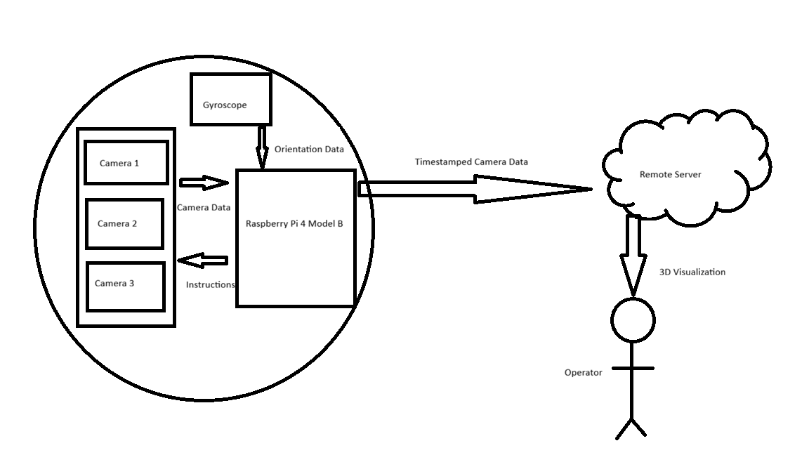
Figure 1: System block diagram depicting flow of information from camera and sensors to computational server to user
At a high level, the system consists of three tightly coupled subsystems:
- Throwable sensor ball
- A 3D-printed spherical enclosure that houses a Raspberry Pi board, three Raspberry Pi Camera Module 3 Wide cameras, and a 10 000 mAh lithium-ion power pack. All electronics are rigidly mounted to survive impact when the ball is thrown into a room and while it is in motion.
- Network and control plane
- Each Pi automatically joins a Tailscale VPN and exposes a REST API and image stream to a central processing server. Time-stamped frames and metadata are transmitted over Wi-Fi.
- Reconstruction and visualization server
- A high-performance workstation with advanced reconstruction software that processes incoming image data to generate and display a real-time 3D reconstruction of the environment for rapid operator assessment.

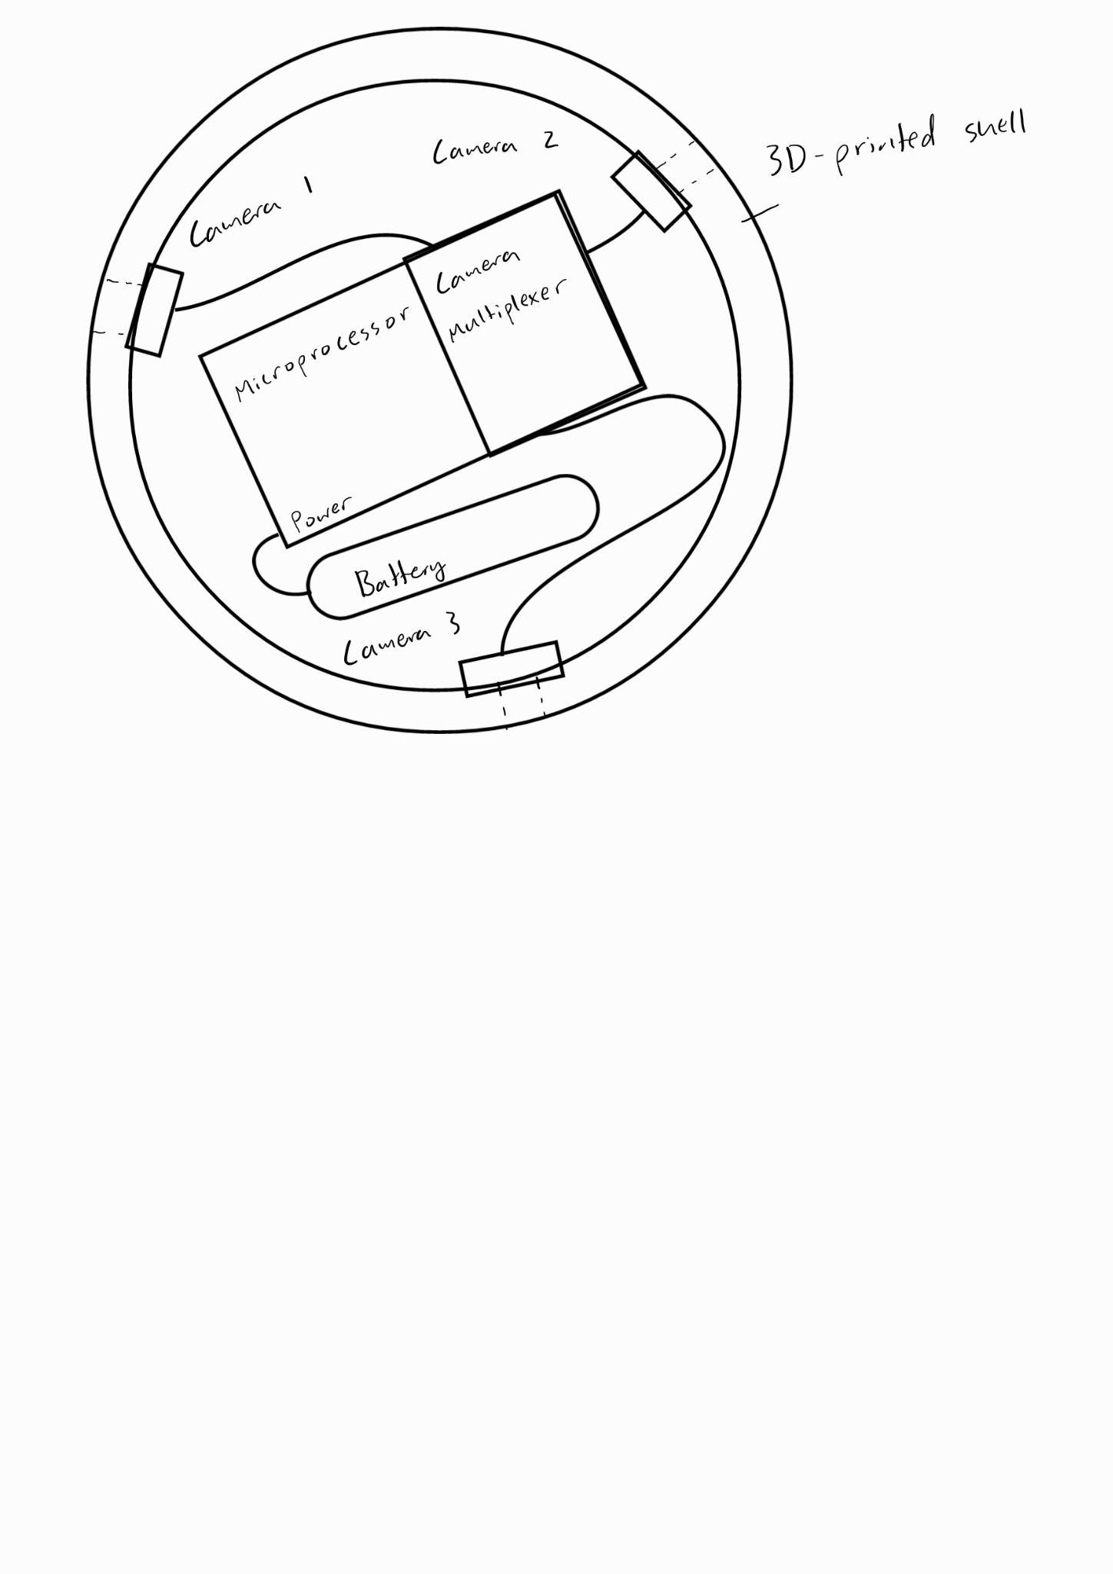
Figure 2: Rough sketch of the ball. The microprocessor is connected to the battery and camera multiplexer. The camera multiplexer is connected to 3 cameras that peak through the shell of the ball, roughly evenly spaced along the equator of the ball.
The sensor ball enclosure is designed to protect all internal components from repeated impacts and external elements like fire, while also staying relatively small to be comfortably thrown. The shell is made of white ABS on a Creality K1 Max printer, chosen for its combination of impact resistance, moderate flexibility, and moderate heat resistance. The cameras are distributed evenly at 120° to provide the greatest field of vision with minimal blind spots. Part of our design is to improve the system’s efficiency by reducing the number of Raspberry Pi single board computers (SBC). The previous iteration of this project had three separate Raspberry Pi Zero 2 W units to service each camera 1:1, because each board only has one port for a camera. Instead, we will utilize a single Raspberry Pi 4, connected to the three cameras evenly via a premade 4:1 multiplexer. This will allow us to synchronize each camera and simplify data transmission. The only downside to this is that we are not able to capture video, but the original design used still shots regardless, effectively resulting in no change.
Also, we can reduce power consumption and improve bandwidth utilization by recognizing that, at most times, one camera will be pointing downwards, as shown in figure 3 if the ball is viewed from the side. This camera’s power can be cut off and we will only have to transmit 2 cameras’ data streams.
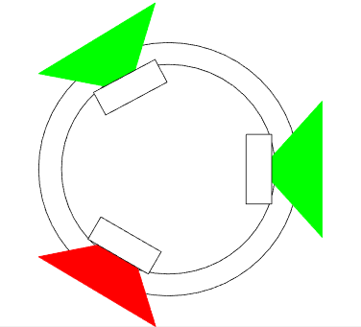
Figure 3: Visualization of how there will almost always be one camera pointing downwards, demonstrating how reduced power consumption can be achieved if camera orientation is known
It is important to note that, if you imagine that if the ball is instead sliced along the hemisphere and viewed top down, all cameras including the red camera in figure 3 would be capturing valuable information.
To implement this camera cutting feature, we need to know the ball’s orientation. A gyroscope or 6 degree of freedom Inertial Measurement Unit (IMU) will work to track the ball’s orientation. This camera cutting feature from IMU will give a more accurate and necessary position of the environment. An accelerometer would not be able to work at the high speed the ball rolls at, and a magnetometer is not necessary. Additionally, computer vision would not be useful since the Raspberry Pi is not capable of running advanced object detection algorithms, and a simple average brightness comparison will not work if the ball passes by dark objects. The Raspberry Pi will be able to take this data and use simple geometry calculations to determine which, if any, camera is currently facing down and stop instructing it to capture images.
The data gathered from the sensor ball will be transmitted over to a remote server via a secure mesh network. This can be established using Tailscale and establishing a connection over the service that would allow the sensor to communicate with the remote server even when connected over different physical Wi-Fi networks. Each transmitted frame is time-stamped and has synchronized data, including IMU orientation data. Time stamps enable accurate alignment for image frames. The network handles potential Wi-Fi bandwidth and signal degradation with buffering and packet management logic. Frames may be compressed to reduce transmission load while still preserving sufficient resolution.
The remote server, a high power workstation with a powerful GPU capable of fast parallel processing, receives images and estimates camera poses with SLAM implementation, then reconstructs the environment using Gaussian-based methods (3D Gaussian splatting today, with a pathway to a 4D Gaussian Transformer). Rather than send the 3D model to the operator, the resulting scene is visualized on the server’s GPU using a visualization client and streamed to the operator in real time, who can then interact with the viewer. This reconstructed 3D environment will be free to view from any angle and will recognize and mark certain object types, such as people.
This also allows animated and inanimate objects to be identified on the map. Threats can be identified by flagging moving objects for the operator to review. Because we are already using a workstation with a GPU for Gaussian splatting, we can also use it for object recognition. Popular methods such as You Only Look Once (YOLO) exist for object detection, but we can also take advantage of having a somewhat stable camera movement due to the ball’s rolling nature. We can estimate camera motion to estimate how objects should change position, and then identify objects that do not fit this assumption to detect motion. While this method works for extremely stable movement like cars or drones, the bouncing nature and changes in direction due to collisions or uneven ground may limit this feature. It will require experimentation to find out which of these algorithms would be more effective and more reliable.

Approach for design validation (1 page, 5 points)
Two main features that we plan to test are durability and function. To ensure that the ball is durable as designed, we will perform drop tests. Because the ball is meant to be rolled rather than thrown upwards, the drop test will only go up to 2 meters, which will be higher than a real user should drop it from. To pass this test, the ball and its contents must be completely undamaged and remain fully functional. Because budget constraints do not allow the repurchase of electronics, stress tests will not be possible. The ball will also be rolled at least 50 times while being operated to ensure that no components come loose while rolling.
To test functionality, we plan to run at minimum the following tests:
- Camera Quality: The images taken by the camera should be checked to ensure that they clearly picture the environment and objects in the images are easy to identify. The photos captured by the camera will be compared to the environment to ensure accuracy.
- Wireless transmission: Because the ball is intended to be used remotely, the ball must be capable of transmitting wirelessly from a distance through walls and objects. To test this, we plan to operate the ball through 10m of obstacles and evaluate for latency and data loss.
- User interface: Because our tool is meant to have little operator training required, the user interface must be intuitive and easy to use. To test this, we will use third parties as operators. While the test operators use the system, we will observe them and ask about their experience.
- Mapping algorithms: If the 3D environments are not accurate to the real environment, operators may make decisions based on incorrect information. We will compare the generated environments against measurements of the real one to ensure accuracy.
- Live object identification: Hidden live objects may not be easy for operators to identify. To ensure the system can identify live objects, we will operate it in an environment with humans and or animals, in varying degrees of hiddenness, and compare the generated flagged objects to the real ones to ensure that the system does accurately flag live or moving objects.
- Lifespan test: The device must operate for long enough that it can be used to explore multiple environments and to monitor changes in environments. The ball will be fully charged and operated until it runs out of battery to determine its lifespan.
Each of these tests will be performed first in controlled environments before being tested as a whole in uncontrolled environments. Each test will be performed multiple times to ensure consistency through trials. Both qualitative and quantitative measurements will be taken to determine whether a test has been passed.

Engineering standards (25 points)

Project management (1 page, 10 pts)
To effectively coordinate development efforts, the team is organized into specialized sub-teams: Hardware & CAD Designing and Software Development. The Hardware team focuses on physical design, component integration, and power system specifications to ensure physical functionality. While the Software subtree is further divided into three specialized areas: Computer Vision & SLAM, Embedded Systems & UI, and Networking & Streaming in order to address the system’s complex software requirements. These specialization aligns team members to their qualifications and interests:

Antony Quach - Hardware & CAD
- Project role: Team lead
- Qualifications: Senior Computer Engineering, Microcomputer Systems, Analog Electronics
- Responsibilities: Design inner mounting of camera modules, Pi board, position sensor (IMU), CAD design for any shell modifications needed, plan and document component connections and physical assembly, calculate power capacity requirements, camera switching circuitry and power cutoff verification, document hardware assembly procedures with photographs
Kiet Nguyen - Hardware & CAD
- Project role: Finance & Purchases
- Qualifications: Senior Computer Engineer, Microcomputer Systems, Analog Electronics
- Responsibilities: Design inner mounting of camera modules, Pi board, position sensor (IMU), CAD design for any shell modifications needed, plan and document component connections and physical assembly, calculate power capacity requirements, camera switching circuitry and power cutoff verification, document hardware assembly procedures with photographs

Brandon Le - Software: Computer Vision & SLAM Lead
- Project role: System Design Architect
- Qualifications: Senior Computer Engineer, Computer Graphics, Microcomputer Systems
- Responsibilities: Simultaneous Localization and Mapping (SLAM) algorithm implementation, 3D map generation and visualization, develop objective detection and classification pipeline to differentiate animate vs. inanimate objects, integrate computer vision libraries with Pi, process IMU orientation data to determine ball position in 3D space, implement camera selection logic (cuts off camera facing ground via IMU data)

Hai Yen Nguyen - Software: Embedded Systems & UI Developer
- Project role: Testing Coordinator
- Qualifications: Senior Computer Engineer, Prev SWE Intern @ USAA, Foundation of Software Engineering
- Responsibilities: User Interface design to view results, develop sensor data processing pipelines for camera feed management, write firmware for Pi to handle camera multiplexer switching, implement real-time display of detection results and 3D maps, implement sensor (IMU) data with camera selection, develop data buffering and storage management for captured images, IMU calibration routine for accurate orientation sensing

Josh Wu - Software: Networking & Streaming Lead
- Project role: Technical Reporting & Documentation
- Qualifications: Senior Computer Engineer, Prev SWE Intern @ Energy Systems Lab, Charles Schwab
- Responsibilities: Real-time data processing, backend API development for remote data access and control, camera feed synchronization, stream IMU data alongside camera feeds (debugging purposes), optimize data compression for efficient storage, log power consumption metrics and camera switching events

While each team member has a primary technical role, all team members (as computer engineers) actively participate in product testing, debugging, and documentation across all subsystems. This ensures comprehensive system validation and knowledge sharing since there are cross dependencies between some areas of hardware and software (such as IMU sensor placement and orientation accuracy for mapping out environment and cutting off camera).

To manage this project as a team, the following mechanisms are used:
- Weekly team meetings: Structured agenda with updates, progress review from sheets, any questions or concerns needed to review, discussion of design decisions and reviewing upcoming week’s priorities, documenting action items with assigned owner and deadline.
- Task tracking: Github will be used to track all coding documentation and changes, while a shared google spreadsheet will be used to track overall task progress and individual team member’s task progress to ensure transparency and accountability.
- Communication: Discord will be used for daily communication and coordination with dedicated channels for general communication, hardware, software, testing, and sharing useful links and notes.

Schedule of tasks, Pert and Gantt charts (1 page, 5 pts)
At a high level, we plan to spend the first couple weeks exploring and testing the limitations of the current design, the following four for implementation, and the final four for testing and iterating on our design. We need to dedicate two weeks to exploring our design because we need to identify hardware-related bottlenecks of the system before we purchase any hardware. Following this, we will spend four weeks upgrading the ball and adding our own features, including updating the CAD to add housing for our new hardware, writing the multiplexing logic, and adding live object recognition. Finally, the last four weeks are meant to give us ample time to iterate on our design and find improvements. We can also use the time to ensure we can purchase more hardware in case anything is faulty.
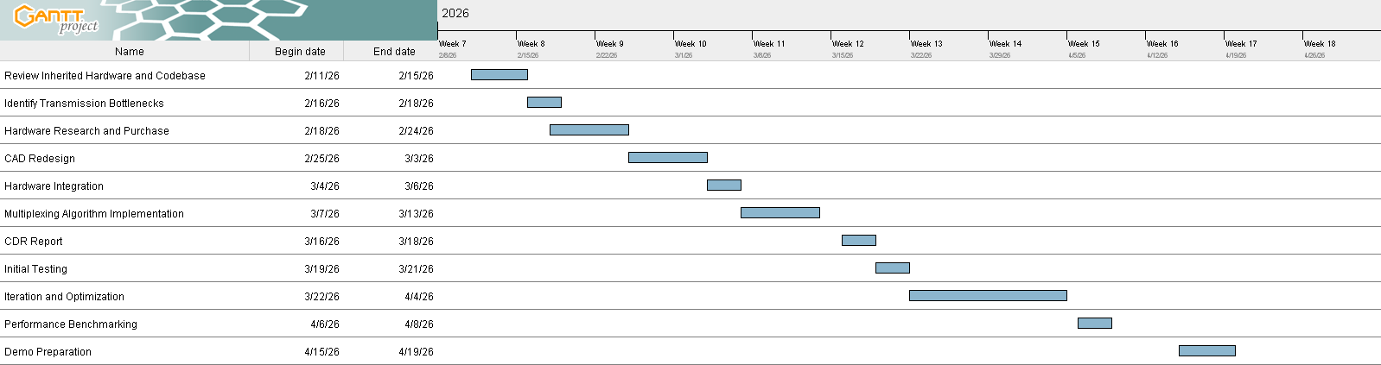
Figure 4: Gantt chart depicting the tasks needed to complete the project and the schedule for each part.

Economic analysis (1/2 page; 3 pts)
Economic viability: The system will be highly marketable because of its advantages compared to competitors: limited training requirement while providing accurate visualization of hazardous environments. The limited training requirement will likely be very attractive to customers because alternative visualization products require a skilled operator to control the device. The price of the ball will also be relatively low due to the low production cost compared to alternatives. The ball can be produced for less than $250, while current competitors’ products cost upwards of $2,000. This leaves room for a large profit margin while maintaining a fair price. After the formalization of product design and production setup, the price to create a single unit will likely be under $175. The easiest way to save cost would be to create our own camera multiplexer by using currently available 2:1 multiplexers which cost around $1 compared to the $50 estimated cost for the prebuilt multiplexer, although that might introduce some reliability issues. Beyond that, using custom PCB and cameras instead of Raspberry Pi parts would likely require huge startup costs but yield a very cheap end product.

Sustainability viability: The product displays high sustainability due to its widespread component availability. The Raspberry Pi 4 microprocessor is globally available from multiple authorized distributors such as Adafruit and Canakit. The Pi Camera Module 3 Wide components have numerous compatible third-party alternatives such as Arducam modules, eliminating single-vendor dependencies and allowing greater flexibility in selecting components. In addition to this, camera multiplexers, battery banks, and 3D-printing filaments are also globally available and produced by various manufacturers, offering countless compatible alternative components that meet any specifications for certain budgets, scopes, and needs. Using commercially available, multi-vendor components, the product ensures supply chain sustainability and component interchangeability. This ensures long-term part availability and ease of replacing faulty components or upgrading for future considerations.
Due to solid-state electronics with no moving parts within our product, the system requires minimal ongoing maintenance. Primary maintenance needs include battery bank replacement approximately every 18-24 months under regular use, periodic camera lens cleaning after field deployment under various conditions and environments, and standard software updates through the Raspberry Pi operating system. The 3D-printed shell should be regularly inspected for stress fractures or damage, with damaged segments being easily reprinted and replaced without use of specialized tools.
Support relies on the open-source Raspberry Pi ecosystem, where users have access to comprehensive community documentation, active forums, and freely available Python libraries (such as OpenCV and picamera2) for troubleshooting and features. These require no fees or subscription and all software receives routine security updates. This extensive open-source foundation enables user self-sufficiency in maintenance and troubleshooting while eliminating long-term support costs.

Manufacturability: Because we have few custom parts, almost all of our components have very high reliability. The 3D printed shell is the only custom component and likely has the most variation of any part of the design. At scale, however, we would likely use a mold to reliably manufacture the shell, reducing variation greatly. Arducam, the manufacturer of the camera multiplexer planned to be used in our prototype, mentions that the multiplexer may have stability issues due to the cable’s signal integrity and Raspberry Pi’s closed source video core libraries. If this is still used at scale, then this would be another source of variation.
In the worst case scenario, incorrectly made shells could result in components not fitting and misconnected wires and poor soldering could render some units faulty. If purchased electrical components are faulty, these can be returned to the vendors for replacement, which will not decrease yield. Yield can likely reach about 90%.
To test the system during manufacturing, we can run scripts on the Raspberry Pi to check that the cameras and IMU are working properly. Wires and connectors can be verified by electrical continuity tests. The cameras and IMU can be calibrated to ensure that they are in the correct orientation.
The final product will likely need to use something other than Wi-Fi, which our prototype will use. Depending on what changes, the wireless communication method must comply with FCC regulations, including not interfering with other wireless devices. Regulations regarding lithium-ion batteries also need to be followed to ensure safe usage of these materials. The product already is fairly electrically safe and will use heat shrink to provide insulation.

Societal, safety and environmental analysis (1/2 page; 2 points)
The societal impact of the proposed project enhances first responder safety and improves the chances of mission success in hazardous environments. By providing rapid, high-quality situational awareness, the device enables faster and more informed decision-making during emergency operations, which can reduce injuries, save lives, and improve overall mission outcomes. Additionally, its low cost and minimal training requirements make it highly scalable and accessible to a wide range of departments and agencies. This allows for rapid deployment across communities, expanding the availability of advanced safety technology without imposing significant financial or operational burdens.
The safety considerations for this project are important since it involves dangerous situations. Integrated battery protection circuitry will prevent electrical hazards such as overheating, overcharging, or short-circuiting, ensuring safe operation during use and charging. This ensures safe operation during active deployment, charging cycles, and storage. Additionally, the system’s remote operation capability significantly limits direct human exposure to dangerous environments. By allowing first responders to assess hazardous spaces from a distance before entry, the device reduces the likelihood of injury and enhances overall operational safety.
The environmental considerations put this project into a compact 3D printed shell that minimizes material waste to make sure we are only using the necessary amount of material, reducing excess production and scrap. This approach also allows rapid prototyping and iterative improvements without large-scale material consumption. In addition, the use of energy efficient electronics for lower power consumption decreases battery demand, extends operational life, and reduces environmental impact. Together, these design choices demonstrate a commitment to sustainability while maintaining the performance and durability required for emergency response applications.

Itemized budget (1 page; 5 pts)
Table 1: An itemized from-scratch budget based on the expected components needed to complete the project. It does not include resources that can be obtained for free from Texas A&M University (e.g. renting a 3D printing machine)
Item | Quantity | Unit Cost (USD) | Total (USD)
Raspberry Pi 4 Model B, 1GB | 1 | 38.50 | 38.50
Raspberry Pi Camera Module 3 Wide | 3 | 37 | 111
Inertial Measurement Unit | 1 | 5 | 5
Anker Power Bank 5V/3A | 1 | 20 | 20
Multi Camera Adapter Module | 1 | 50 | 50
3D-printer filament (ABS, 1 kg) | 1 | 11 | 11
Solder | - | 5 | 5
Wire spool (22–24 AWG) | 1 | 3 | 3
Misc. fasteners, heat-shrink, etc. | - | ~5 | ~5
Estimated total |  |  | 248.50

References (4 points)
- B Imaging, “Law_Enforcement_Brochure.” Accessed: Feb. 12, 2026. [Online]. Available: https://bounceimaging.com/wp-content/uploads/2024/03/Law_Enforcement_Brochure__Newest_9723_.pdf
- “BRINC Ball,” BRINC, Jan. 30, 2024. https://brincdrones.com/brinc-ball/ (accessed Feb. 12, 2026).
- C. A. Hoehn, “Active Shooter Response Implementation for the Red, White, & Blue Fire Protection District.” https://apps.usfa.fema.gov/pdf/efop/efo248128.pdf
- “Fire-Related Firefighter Injuries (2018-2020),” U.S. Fire Administration, 2018. https://www.usfa.fema.gov/statistics/reports/firefighters-departments/firefighter-injuries-v22i4.html
- Flyability, “Elios 3 Surveying Payload,” www.flyability.com. https://www.flyability.com/elios-3-surveying-payload
- R. Robotics, “The Throwbot® 2,” ReconRobotics. https://reconrobotics.com/products/throwbot-2-robot/
- S. Robotics, “Stationary Robot,” Squishy-robotics.com, 2026. https://squishy-robotics.com/stationary-robot/ (accessed Feb. 12, 2026).

Appendices (1 point)

Product datasheets
Raspberry Pi Camera Module 3: The Raspberry Pi Camera Module 3 will be used primarily because it was an integral part of the previous design. By reusing them, we save cost and are able to use much of the original code that controls the cameras. As far as we know, the quality of the images is not a bottleneck in the 3D environment model quality.

Raspberry Pi Model 4B: The Raspberry Pi 4B is a useful upgrade over the previous Raspberry Pi Zero 2 W. We increase the amount of RAM and the speed of the CPU, reducing bottlenecks associated with transmission between the ball and the server. This upgrade is especially useful since a planned change this semester is to add camera multiplexing logic to the Raspberry Pi’s responsibilities.

Arducam Raspberry Pi Multi Camera Adapter Module V2.2: By using a model 4 Raspberry Pi, we can also use a prebuilt camera multiplexing board like the Arducam Raspberry Pi Multi Camera Adapter Module V2.2. Each Raspberry Pi only has one MIPI CSI camera connection. Our project needs multiple cameras, each requiring their own connection to the Raspberry Pi. This board allows us to overcome the limitation of having only one CSI port on the Raspberry Pi by multiplexing the cameras to a single port.

Bios and CVs
- Brandon Le (CV): Senior Computer Engineering major, Coding Club member, Datathon participant
- Kiet Nguyen (CV) is Senior Computer Engineering major at Texas A&M University. Previously, he has worked for 1Finity (Formerly known as Fujitsu Network Communications) as a software intern, developing proprietary software to accelerate code development.
- Hai Yen Nguyen (CV) is a Senior Computer Engineering major at Texas A&M and former undergraduate researcher for the Aggie Research Scholars program. She previously worked for USAA as a software engineer intern building UI.
- Antony Quach (CV) is a Senior Computer Engineering major at Texas A&M. He currently
- Josh Wu (CV) is a senior computer engineering major at Texas A&M University and former teaching assistant for A&M’s computer science department. Previously, he has worked for the Texas A&M Engineering Experiment Station developing software for energy efficiency in buildings and for Charles Schwab as an intern on data engineering and data science projects in cyber security.

